AWS S3 Access Point
Amazon S3 Access Point is a feature that simplifies managing data access at scale for shared data in Amazon S3. It allows you to create a dedicated access policy for each access point, and you can associate it with a specific bucket and restrict access using VPCs, IAM policies, or resource policies.
Instead of managing complex bucket policies for many users, you can create multiple access points with custom permissions for different applications or teams.
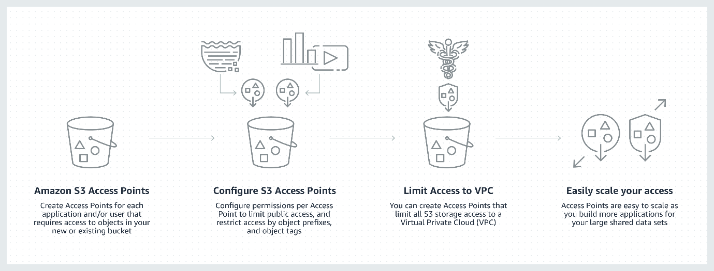
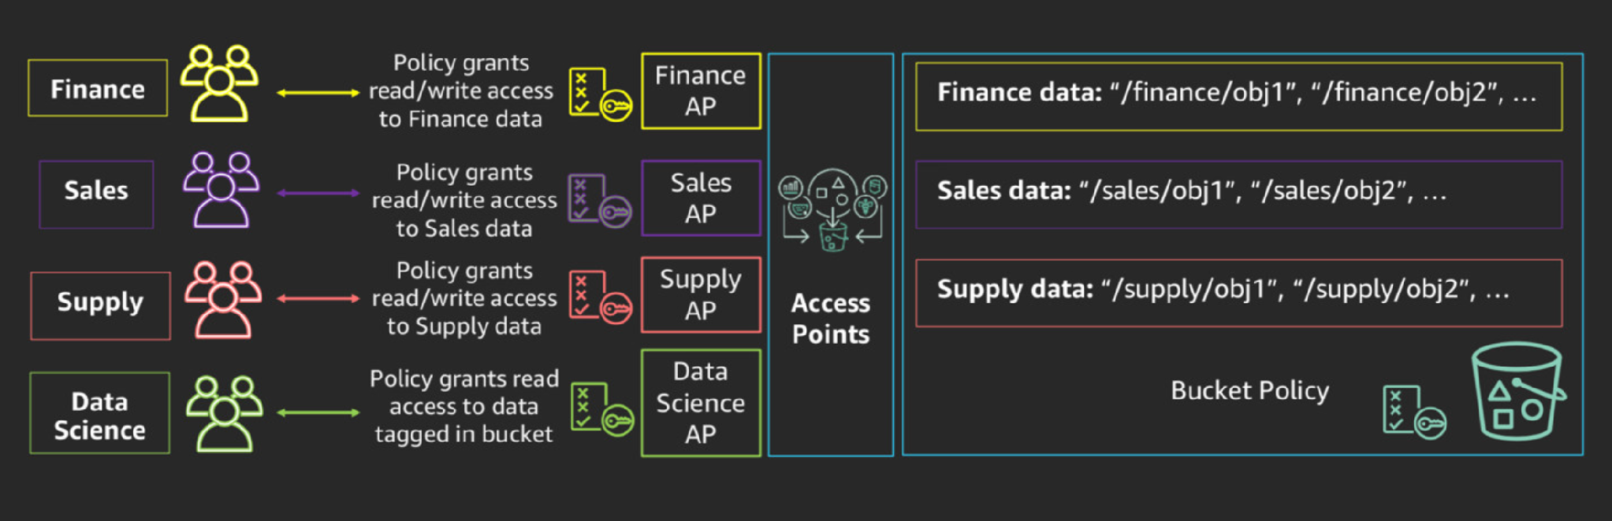
Key Features:
- Each access point has a unique DNS-compliant hostname.
- Policies can be applied per access point.
- Supports VPC restrictions, allowing private access from a specific VPC.
- Great for multi-tenant environments or data lakes.
When Should You Use S3 Access Points?
Use S3 Access Points when:
- You have multiple applications or teams accessing the same S3 bucket.
- You need different permissions or access patterns per team/app.
- You want to simplify your bucket policy.
- You want to enforce VPC-only access to an S3 bucket.

LAB: Create and Verify an AWS S3 Access Point
Objective:
- Create an S3 bucket
- Upload some data
- Create an IAM user with limited access
- Create an S3 Access Point
- Test access via CLI

Lab Setup
1. Create an S3 Bucket
- Go to AWS Console > S3.
- Click [Create bucket]
- Name it: demo-accesspoint-bucket-<your-unique-id>
- Region: Choose your region (e.g., us-east-1)
- Uncheck Block all public access (for testing only)
- Keep other settings default and click [Create bucket]

2. Upload a Sample File
- Click the newly created bucket
- Click [Upload]
- Upload a file, e.g., MyPic01.jpeg
- Click [Upload]

3. Create an IAM User
- Go to IAM > Users > Add users
- Name: testuser
- Select Programmatic access
- Click Next
- Choose Attach policies directly
- Click [Create policy]
Create a Custom Inline Policy:
{
"Version": "2012-10-17",
"Statement": [
{
"Sid": "AllowAccessPointRead",
"Effect": "Allow",
"Action": "s3:GetObject",
"Resource": "arn:aws:s3:us-east-1:AWS-ACCOUNT-ID:accesspoint/demo-access-point/object/*"
}
]
}

Replace:
- AWS-ACCOUNT-ID with your AWS account number
Then:
- Save policy and attach to testuser
- Download the Access Key and Secret Key
4. Create an S3 Access Point
- Go to S3 > Access Points > Create Access Point
- Name: demo-access-point
- Bucket: demo-accesspoint-bucket-<your-unique-id>
- Network Origin: Internet (for now)
- Keep default settings, click [Create Access Point]

5. Test with AWS CLI as the User
Configure CLI with IAM user credentials:
aws configure --profile testuser
Enter access key, secret, region (e.g., us-east-1), and output format (json)
Try Accessing Object via Access Point:
aws s3api get-object --bucket arn:aws:s3:us-east-1:637429913956:accesspoint/demo-access-point --key MyPic01.jpeg test-downloaded.jpeg --profile testuser

OPTIONAL: Add Bucket Policy (only if needed)
Sometimes, the bucket's bucket policy blocks access even if IAM policy allows it. If that's the case, you can allow access via the access point in the bucket policy.
Go to S3 > Your Bucket > Permissions > Bucket Policy, and add:
{
"Version": "2012-10-17",
"Statement": [
{
"Sid": "AllowAccessPointAccess",
"Effect": "Allow",
"Principal": {
"AWS": "arn:aws:iam::637423313956:user/testuser"
},
"Action": "s3:GetObject",
"Resource": "arn:aws:s3:::demo-accesspoint-bucket-1860/*"
}
]
}

What is AWS S3 Multi-Region Access Point(MRAP)?
An S3 Multi-Region Access Point (MRAP) is a global endpoint that routes S3 requests automatically to the nearest or most optimal AWS Region where you have replicated your data.
It is designed for globally distributed applications to:
- Reduce latency
- Improve fault tolerance
- Increase availability
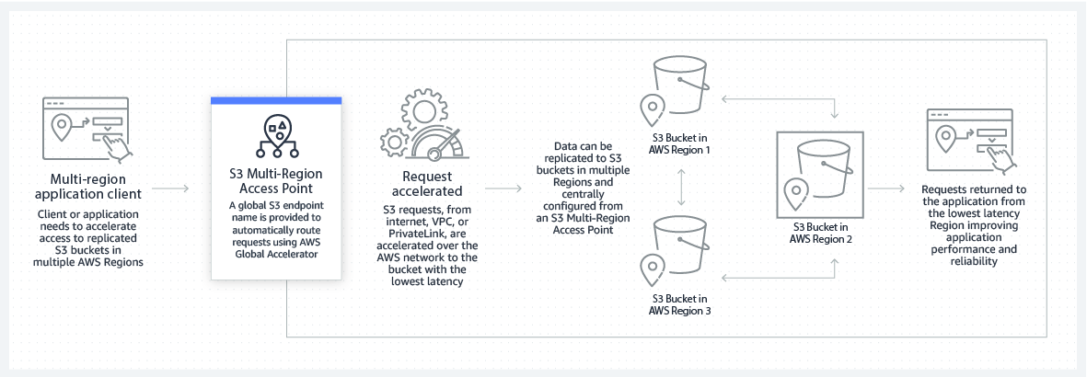
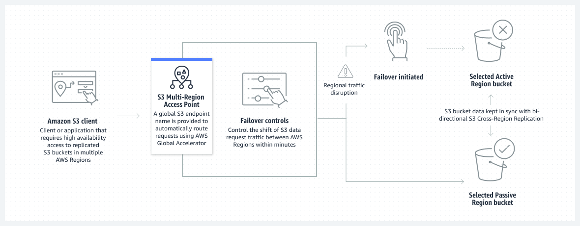

How It Works
- You create buckets in multiple AWS regions and replicate data between them (using S3 Replication).
- Then you create a Multi-Region Access Point that aggregates those buckets under one global access point.
- When users or applications access data through the MRAP, AWS automatically routes the request to the closest region with the data.

Difference Between Access Point and Multi-Region Access Point
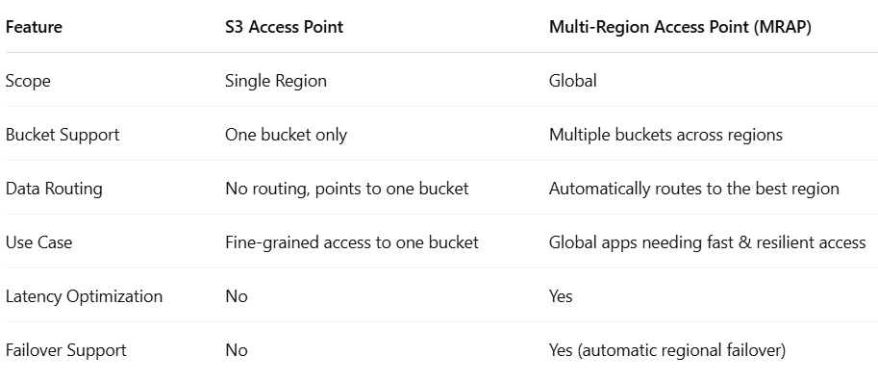
Advantages of Multi-Region Access Point

Global Data Access

Access the same data from multiple regions with one endpoint.

Low Latency

Requests are served from the nearest AWS region with data.

High Availability

If one region goes down, AWS routes traffic to another region.

Simplified Access

Use a single access point for all regions instead of managing multiple endpoints.

Resilience & Disaster Recovery

Works with S3 Cross-Region Replication for resilient, fault-tolerant architectures.

When Should You Use Multi-Region Access Point?
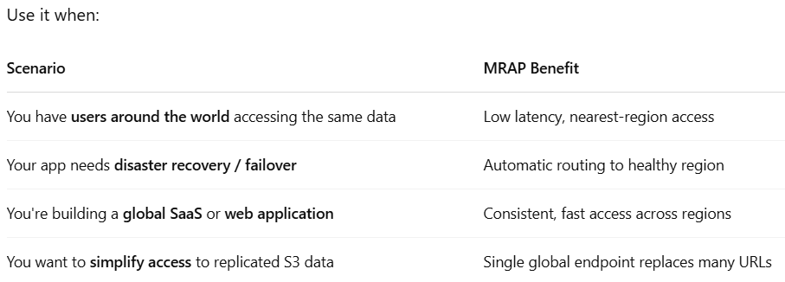

Example Use Case: Global Media Delivery App
You run a photo-sharing platform with users in:
- North America (us-east-1)
- Europe (eu-west-1)
- Asia (ap-southeast-1)
You replicate data between these S3 buckets. Now, instead of asking users to hit regional buckets, you create a Multi-Region Access Point.
When a user from Europe uploads or downloads a photo, it is automatically routed to the eu-west-1 bucket.

LAB: Create and Test an AWS S3 Multi-Region Access Point

Prerequisites
- AWS CLI installed and configured
- IAM user/role with full S3 and S3 Control permissions
- Two AWS Regions (e.g., us-east-1 and eu-west-1)

Step 1: Create Two S3 Buckets in Different Regions
aws s3api create-bucket \
--bucket mrap-demo-bucket-useast1 \
--region us-east-1 \
--create-bucket-configuration LocationConstraint=us-east-1

aws s3api create-bucket \
--bucket mrap-demo-bucket-euwest1 \
--region eu-west-1 \
--create-bucket-configuration LocationConstraint=eu-west-1

Make sure bucket names are globally unique.

Step 2: Enable Versioning on Both Buckets
Required for Cross-Region Replication.
aws s3api put-bucket-versioning \
--bucket mrap-demo-bucket-useast1 \
--versioning-configuration Status=Enabled

aws s3api put-bucket-versioning \
--bucket mrap-demo-bucket-euwest1 \
--versioning-configuration Status=Enabled

Step 3: Set Up IAM Role for Replication
Create a role called s3-replication-role and attach the following trust policy:
{
"Version": "2012-10-17",
"Statement": [
{
"Effect": "Allow",
"Principal": { "Service": "s3.amazonaws.com" },
"Action": "sts:AssumeRole"
}
]
}

Then attach this permissions policy:
{
"Version": "2012-10-17",
"Statement": [
{
"Action": [
"s3:GetObjectVersion",
"s3:GetObjectVersionAcl",
"s3:GetObjectVersionTagging"
],
"Effect": "Allow",
"Resource": "arn:aws:s3:::mrap-demo-bucket-useast1/*"
},
{
"Action": [
"s3:ReplicateObject",
"s3:ReplicateDelete",
"s3:ReplicateTags"
],
"Effect": "Allow",
"Resource": "arn:aws:s3:::mrap-demo-bucket-euwest1/*"
}
]
}

Step 4: Enable Cross-Region Replication (CRR)
Create a replication rule on the source bucket (us-east-1) pointing to the destination bucket (eu-west-1).
{
"Role": "arn:aws:iam::<YOUR_ACCOUNT_ID>:role/s3-replication-role",
"Rules": [
{
"ID": "replicate-to-eu",
"Status": "Enabled",
"Priority": 1,
"DeleteMarkerReplication": { "Status": "Disabled" },
"Filter": {},
"Destination": {
"Bucket": "arn:aws:s3:::mrap-demo-bucket-euwest1"
},
"SourceSelectionCriteria": {
"SseKmsEncryptedObjects": {
"Status": "Disabled"
}
}
}
]
}
Save this as replication.json and run:
aws s3api put-bucket-replication \
--bucket mrap-demo-bucket-useast1 \
--replication-configuration file://replication.json

Step 5: Create the Multi-Region Access Point (MRAP)
Create a file mrap-config.json with the following:
{
"Name": "mrap-demo-global",
"Regions": [
{ "Bucket": "mrap-demo-bucket-useast1" },
{ "Bucket": "mrap-demo-bucket-euwest1" }
]
}
Run this command (replace <ACCOUNT_ID>):
aws s3control create-multi-region-access-point \
--account-id <ACCOUNT_ID> \
--details file://mrap-config.json

Step 6: Wait for MRAP to Be Created
Run the following to monitor the status:
aws s3control get-multi-region-access-point \
--account-id <ACCOUNT_ID> \
--name mrap-demo-global
Wait until Status becomes Ready.

Step 7: Upload a Test Object to Source Region
echo "Hello from MRAP!" > hello.txt
aws s3 cp hello.txt s3://mrap-demo-bucket-useast1/hello.txt
Wait a bit for replication to complete (1–2 minutes).

Step 8: Access the Object via MRAP Endpoint
Construct the global endpoint in this format:
https://mrap-demo-global.accesspoint.s3-global.amazonaws.com/hello.txt
Use curl or browser to access:
curl https://mrap-demo-global.accesspoint.s3-global.amazonaws.com/hello.txt
You should see:
Hello from MRAP!

Verification Tips
Task | How to Verify
Data Replication | Check object in destination bucket
MRAP Routing | Use browser/curl from different regions
Latency Optimization | Use AWS CloudShell from multiple regions to test

Cleanup (Optional)
aws s3 rm s3://mrap-demo-bucket-useast1 --recursive
aws s3 rm s3://mrap-demo-bucket-euwest1 --recursive

aws s3api delete-bucket --bucket mrap-demo-bucket-useast1
aws s3api delete-bucket --bucket mrap-demo-bucket-euwest1

aws s3control delete-multi-region-access-point \
--account-id <ACCOUNT_ID> \
--name mrap-demo-global

